# **Expected Value**

## **Problem-1**

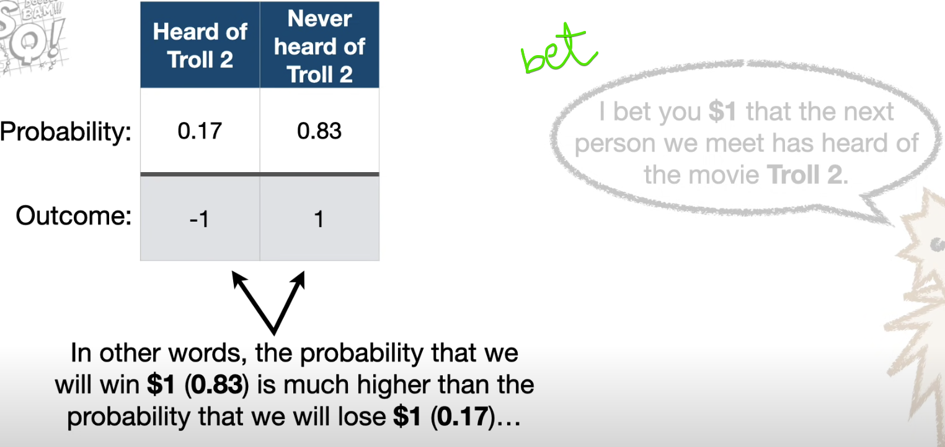

So we will be confident enough to challenge for the bet.

However, even though there is a high probability that we will win the bet (0.82), there is also still a low probability that will lose (0.17).

Lets repeat this $1bit for 100 times.

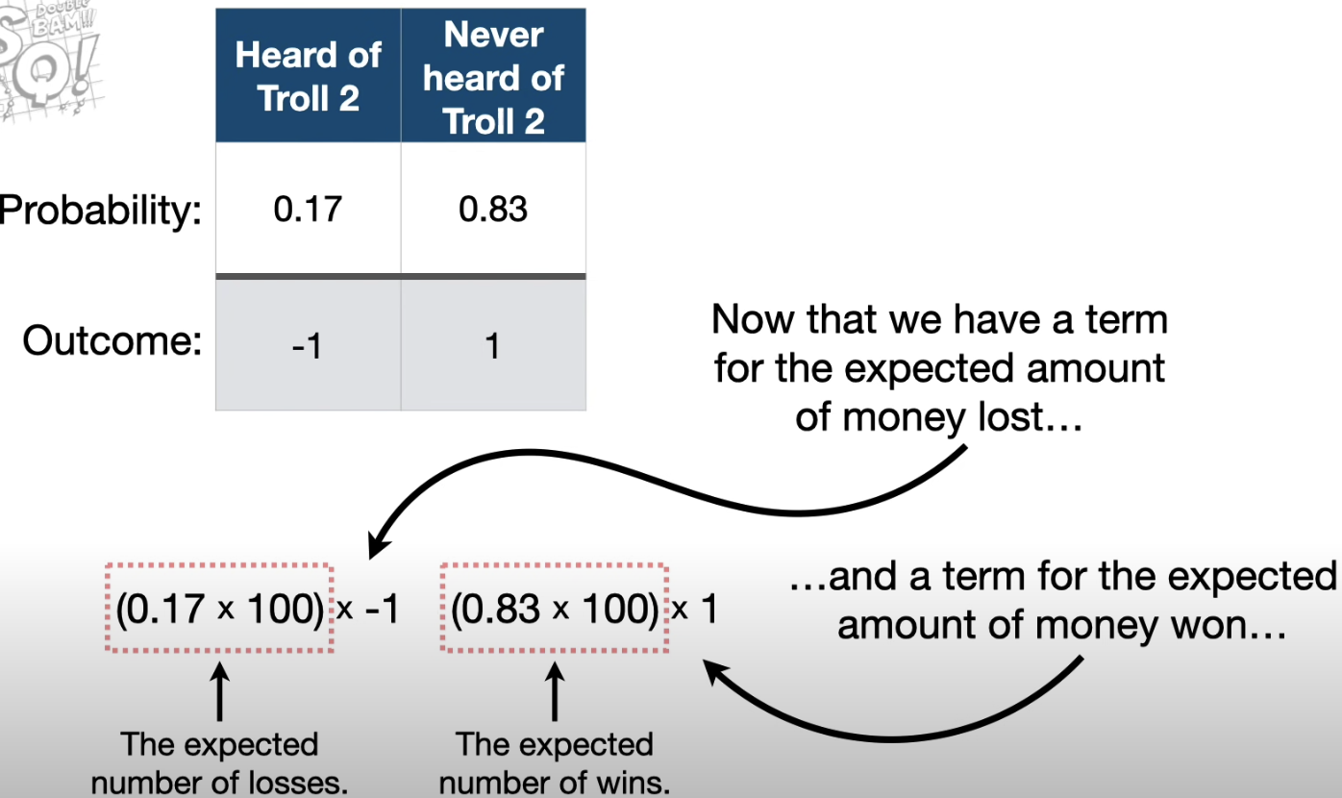

We can add up these two terms to find out the total of how much we except to win/lose.

Amount earned after 100 bets 🡪 $66  
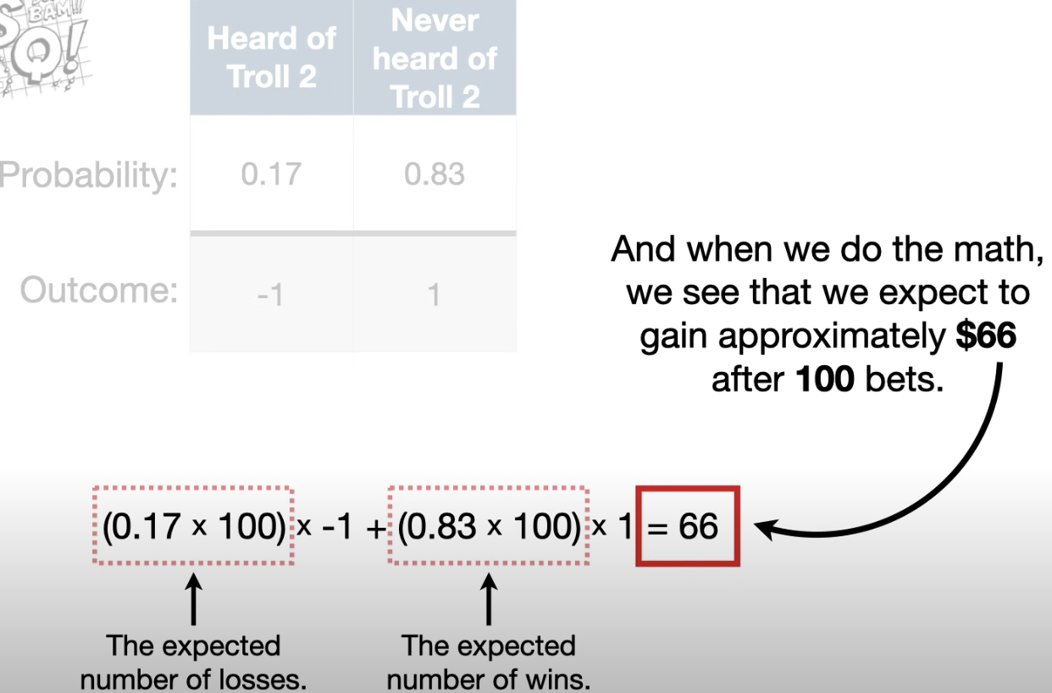

Average amount earned per bet 🡪 $ 0.66  
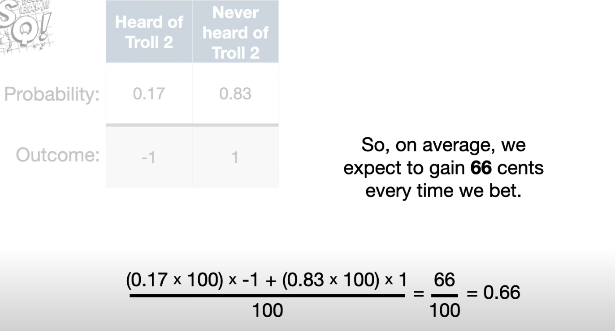

Even-though I win or lose $1 each time I bet. On an average I expected to gain 66 cents each time.

0.66 🡪 Expected cents is the expected value for the bet.

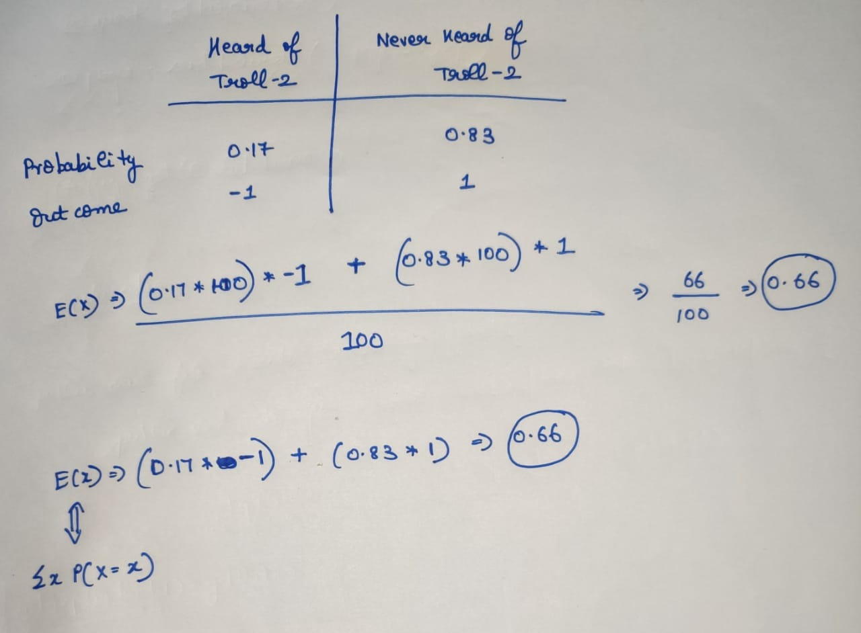

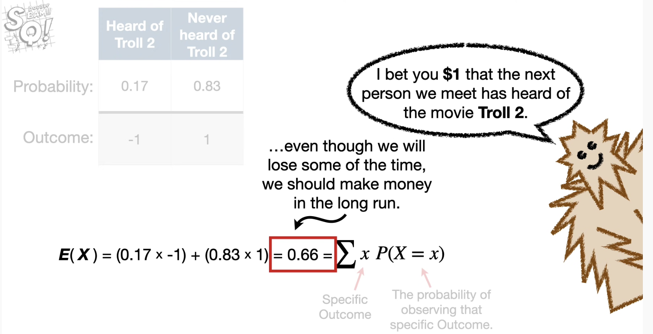

## **Dive into complex problem-2**

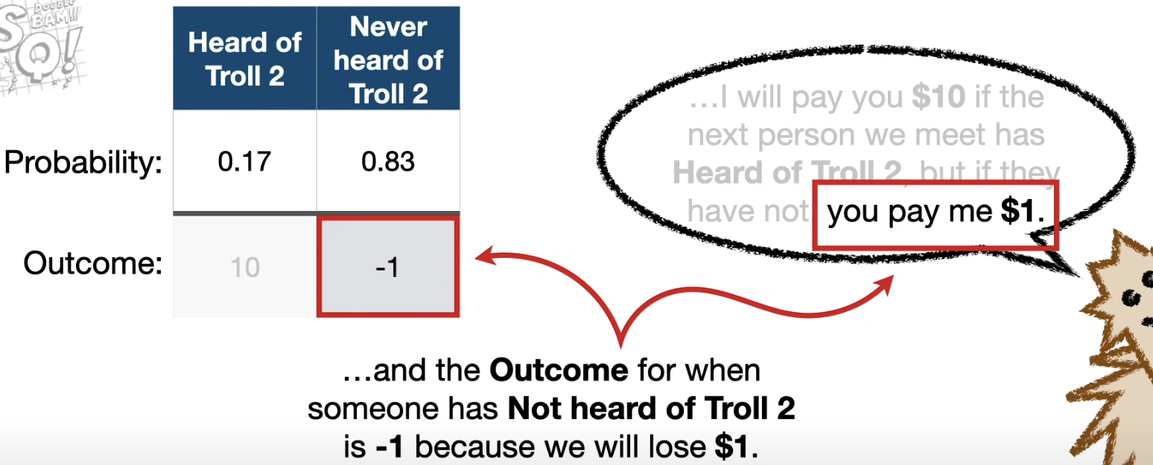

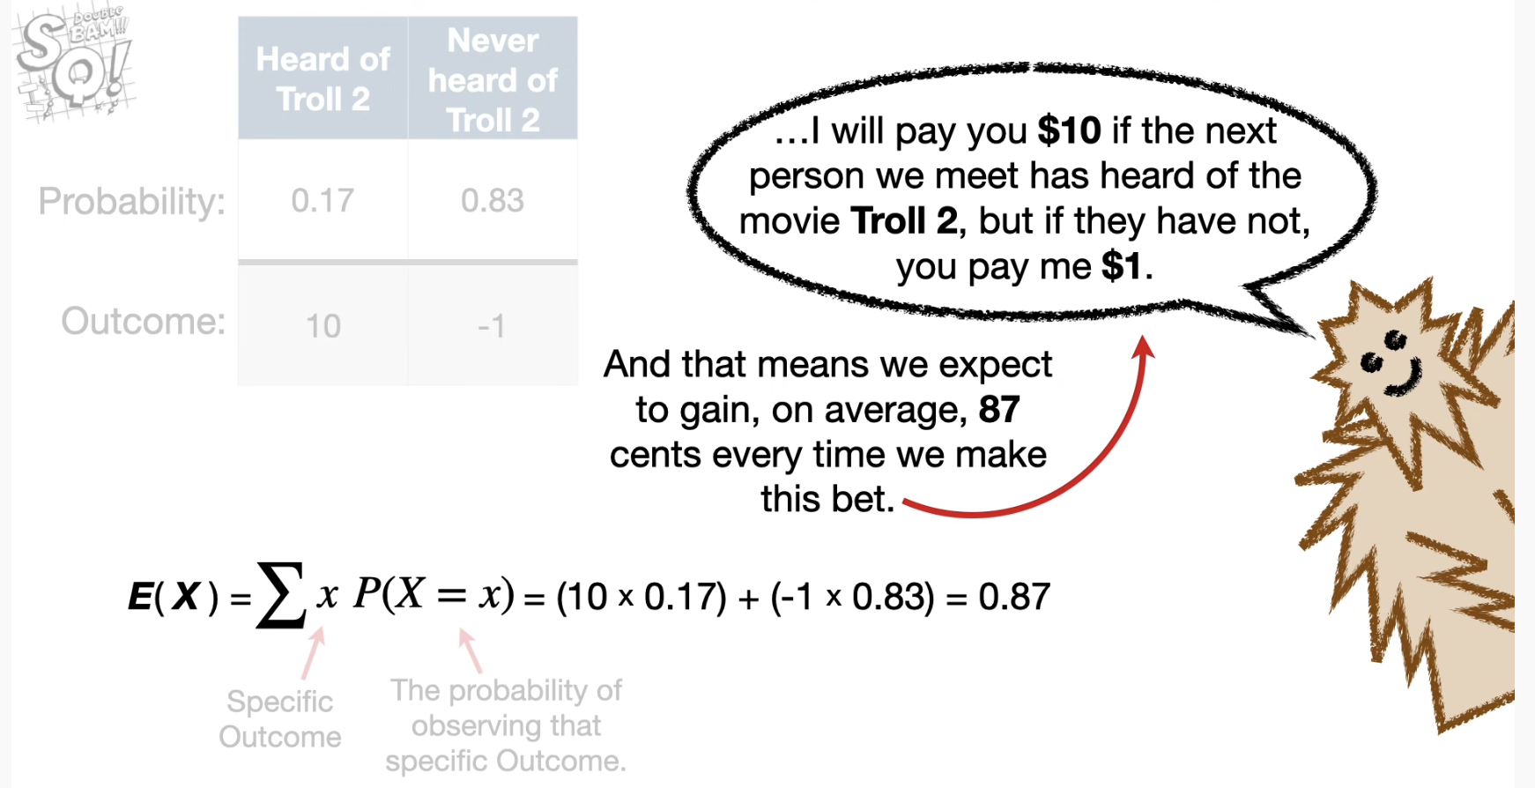

Till now we covered to calculate the Expected value for discrete variables.

# **Entropy**

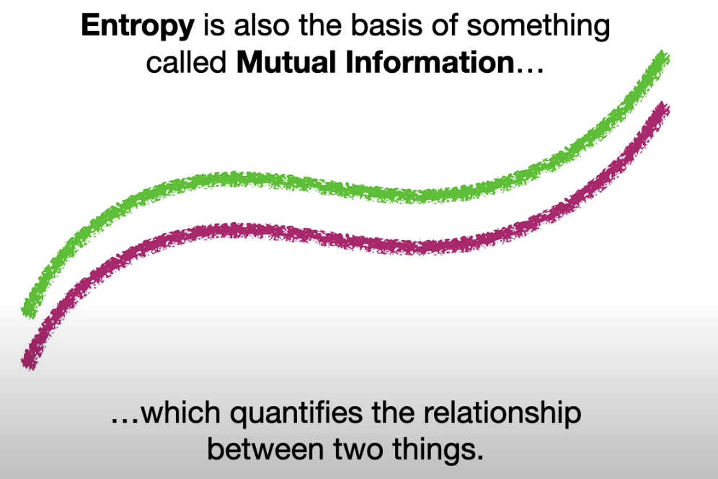

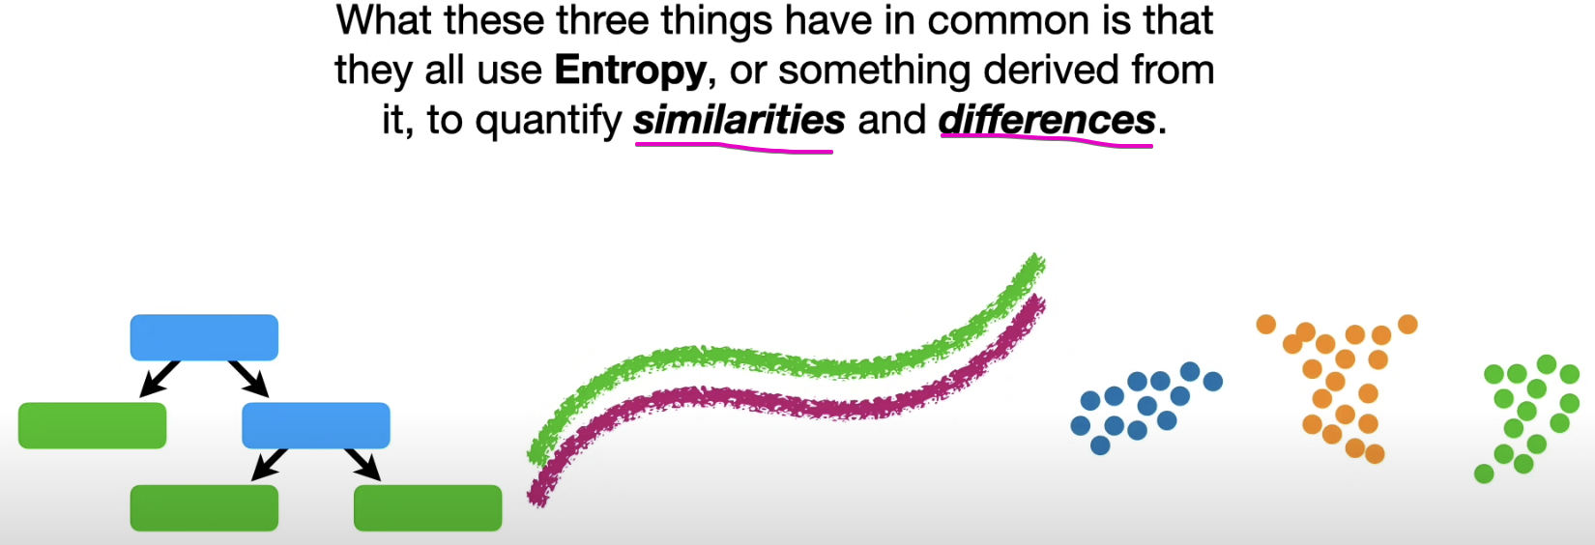

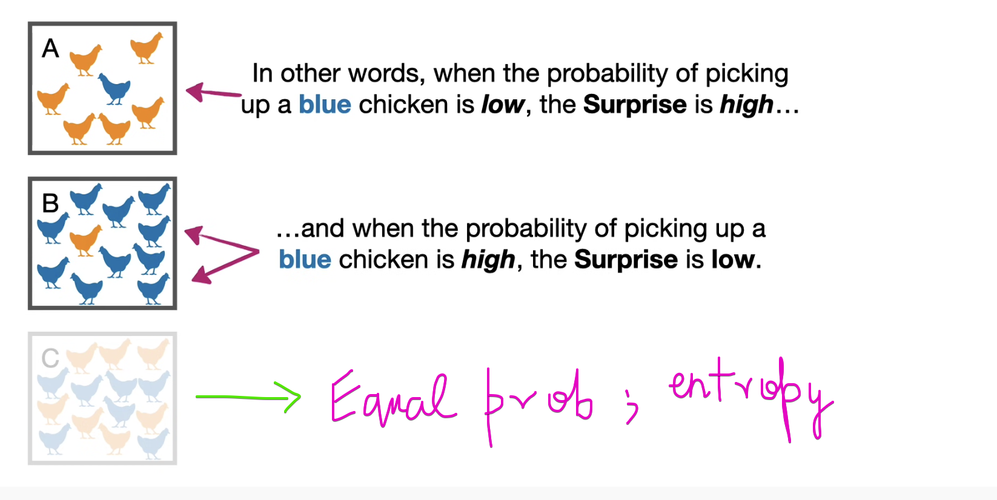

Probability is inversely proportional to surprise.

## **Problem-1**

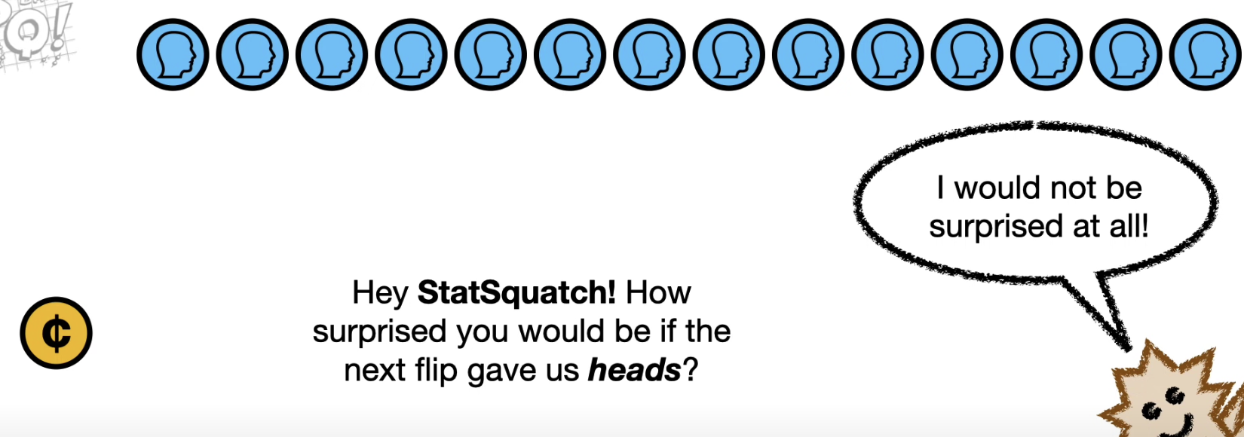

Probability(Heads) = 1, then we want the Surprise(Heads) = 0.

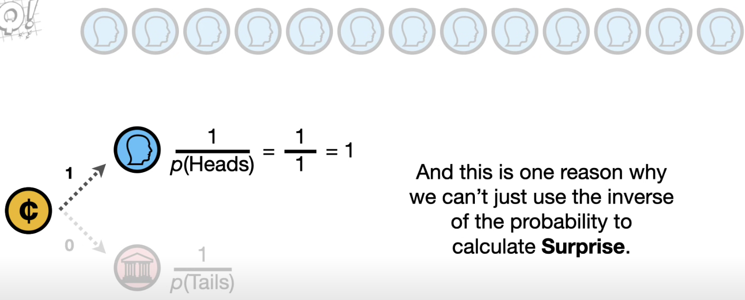

But we are not getting Surprise=0.   
So taking the inverse of Probability != Surprise

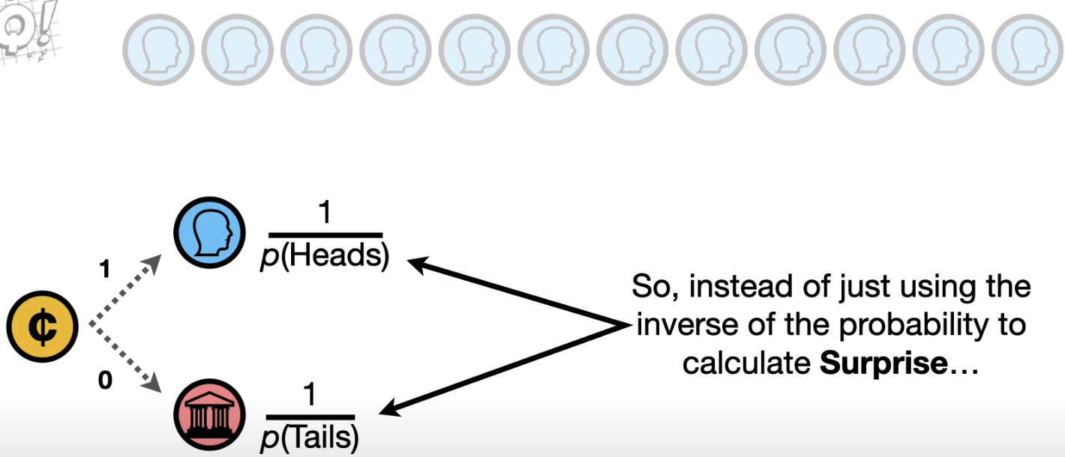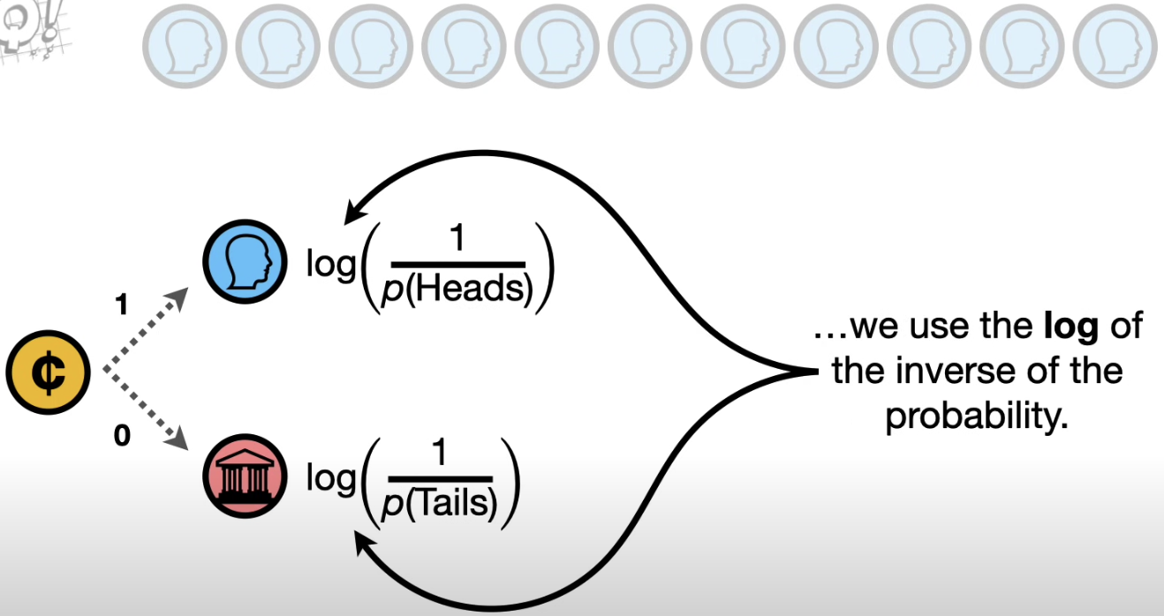

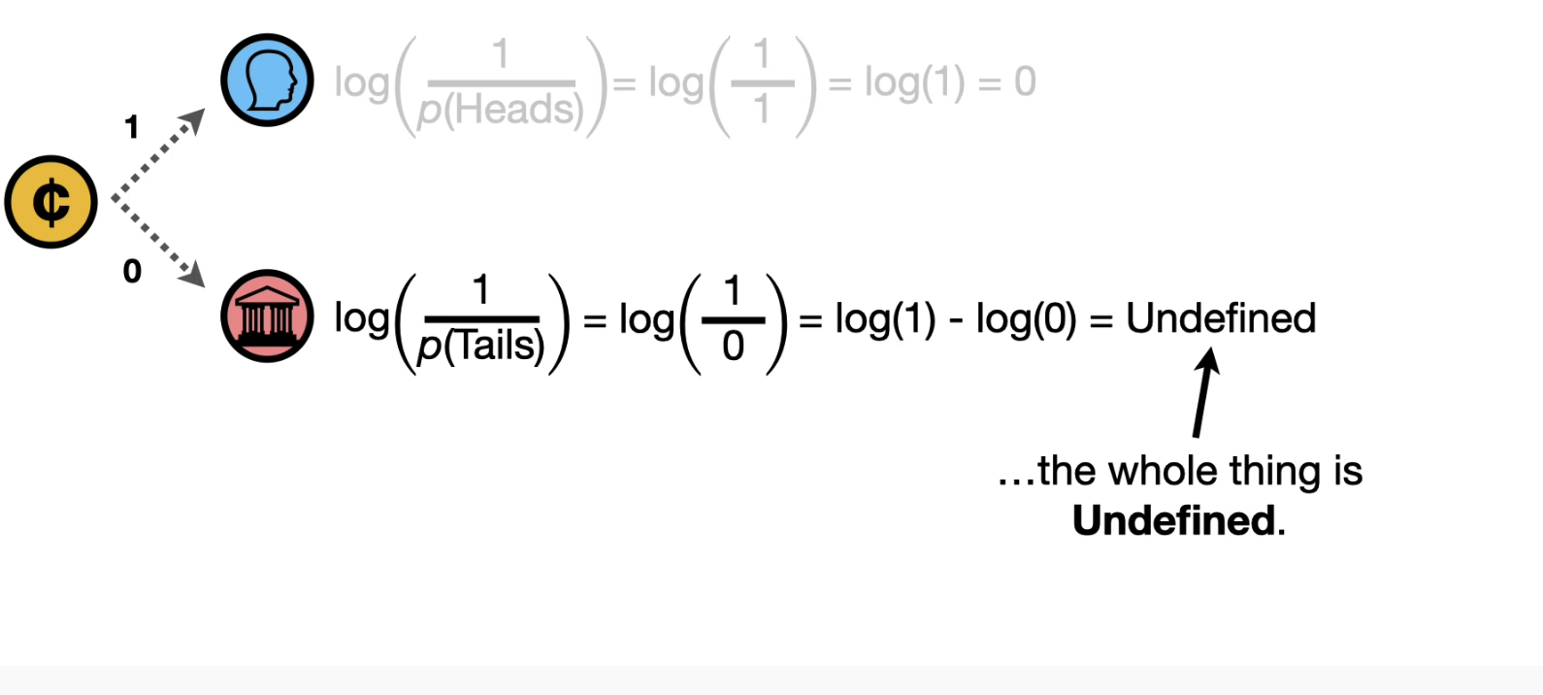

And this result is OK, because we are talking about the **Surprise** associated with something that never happens.

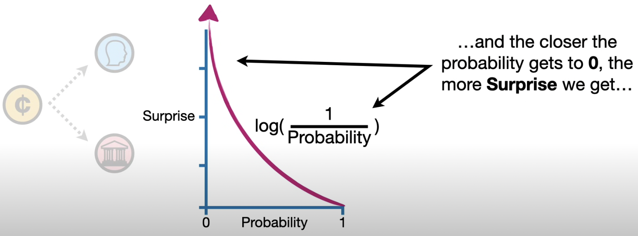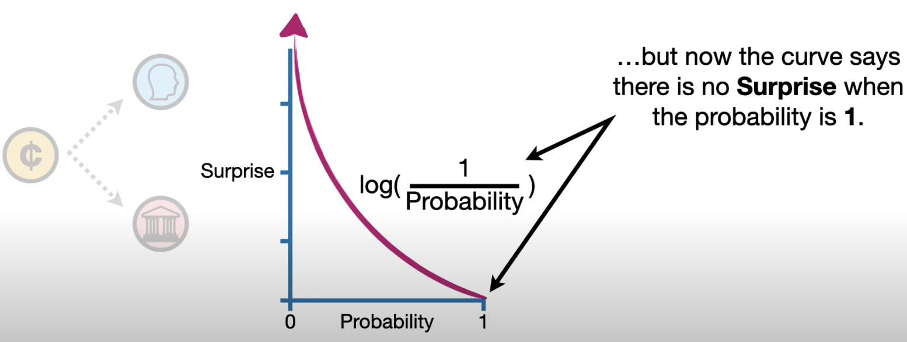  
There is a little gap. There is no gap.

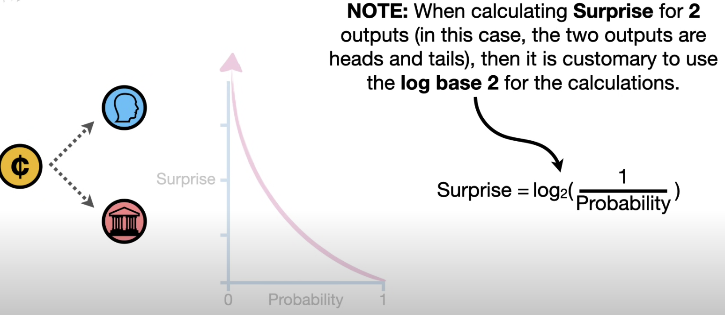

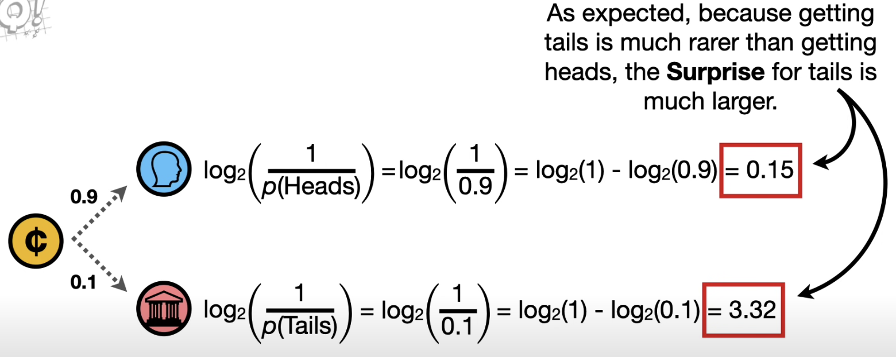

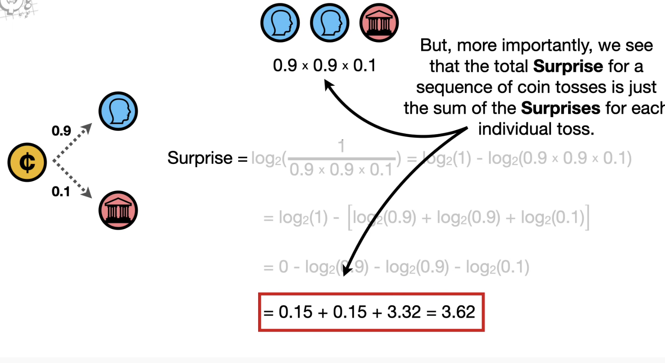

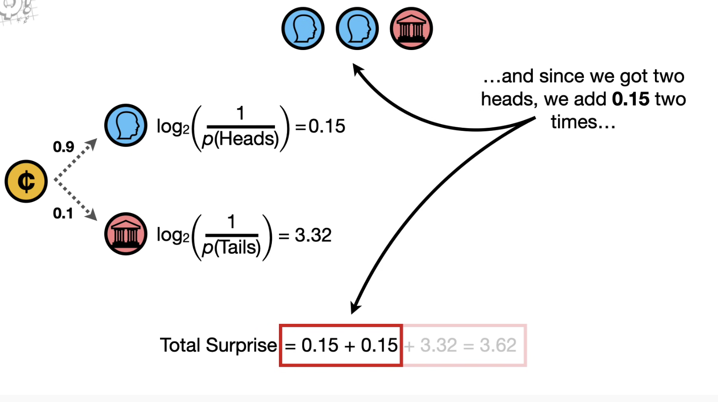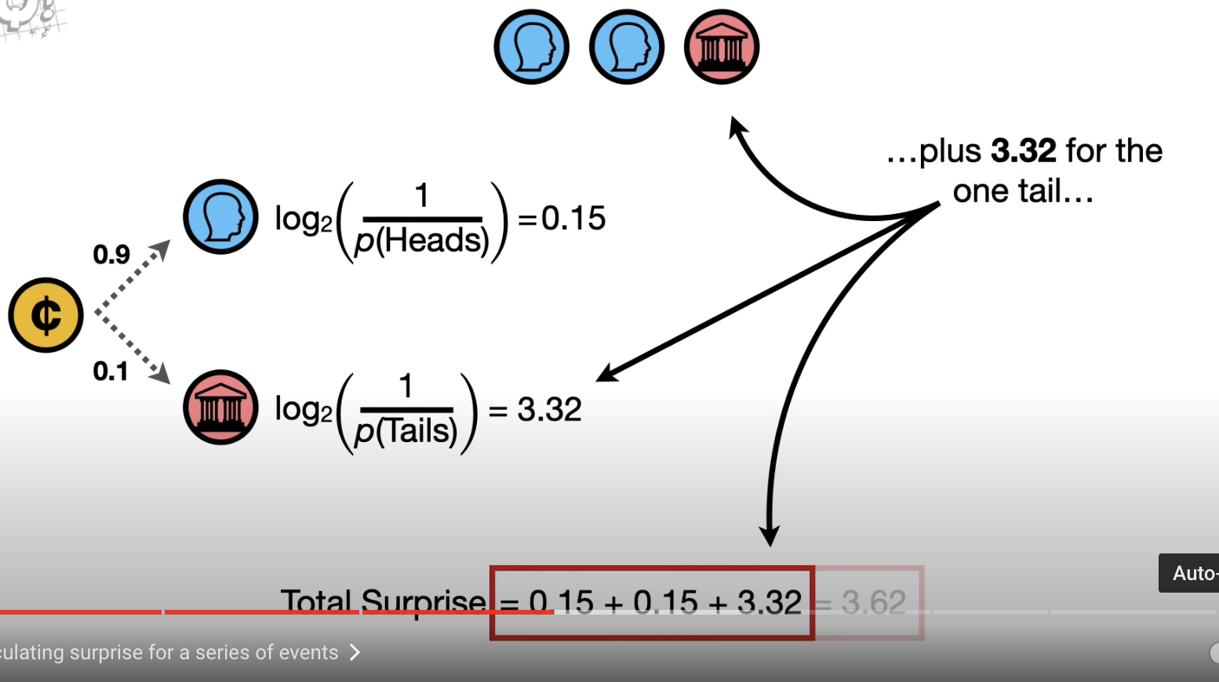

Suppose we repeat the experiment 100 times.

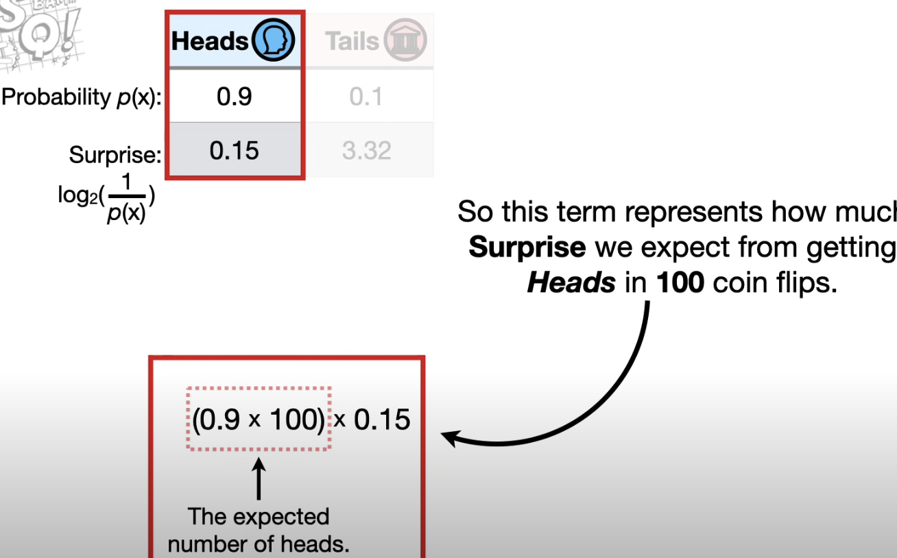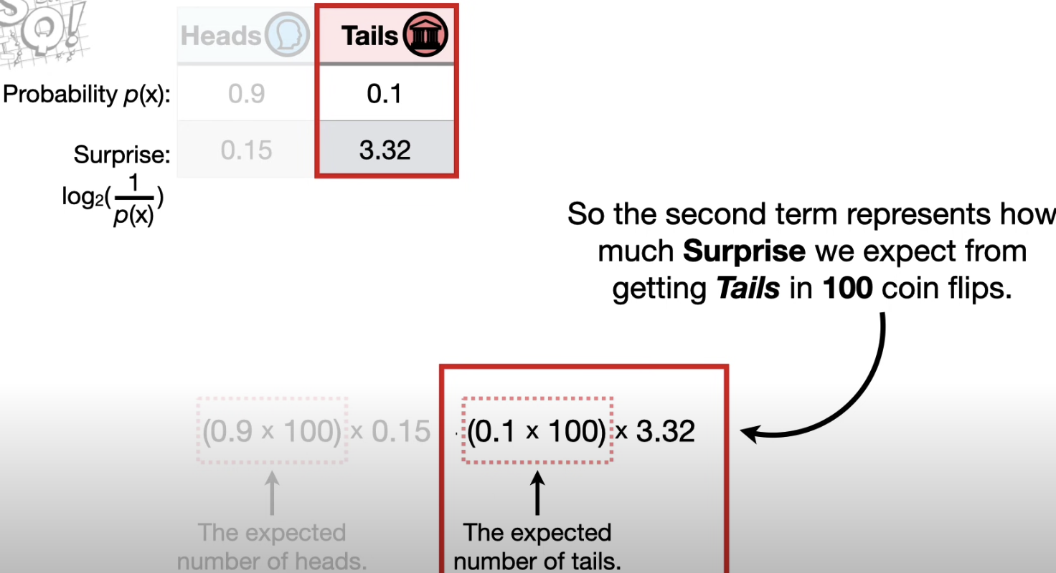

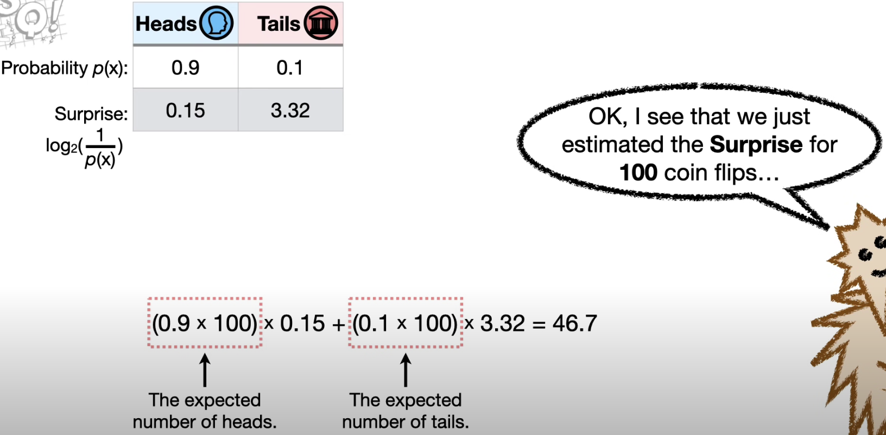

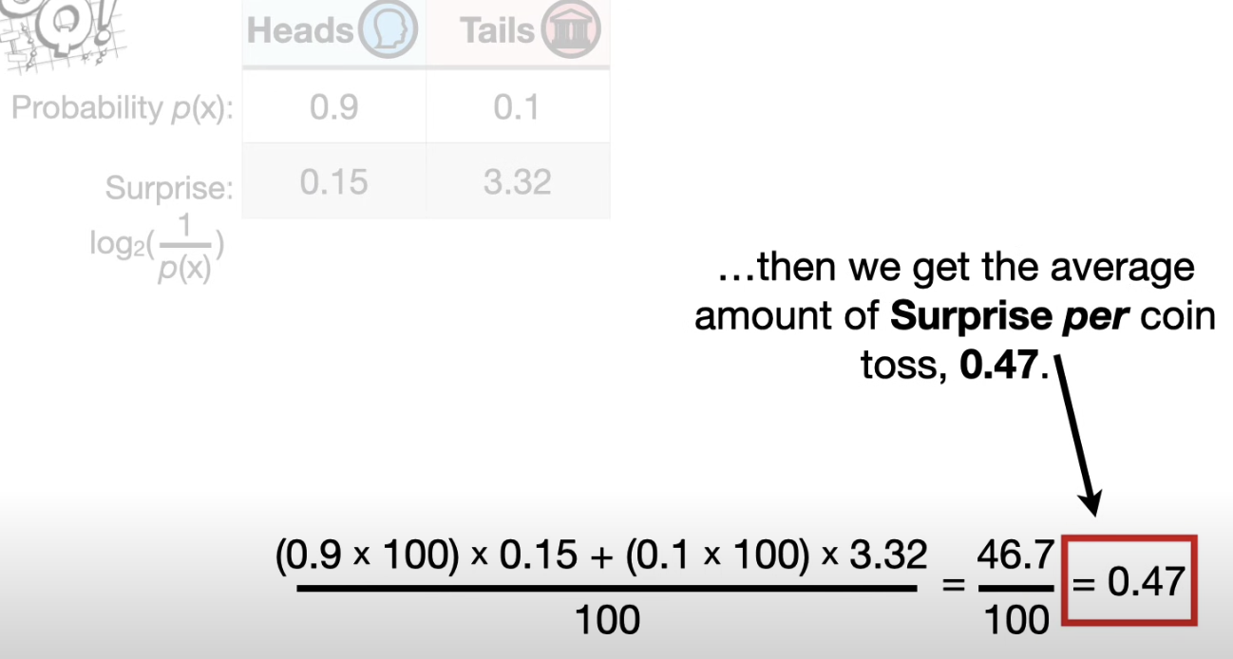

So on an average, we except the Surprise to be 0.47 every time we flip the coin. 🡪 Entropy of the coin (Expected Surprise every time we flip the coin)

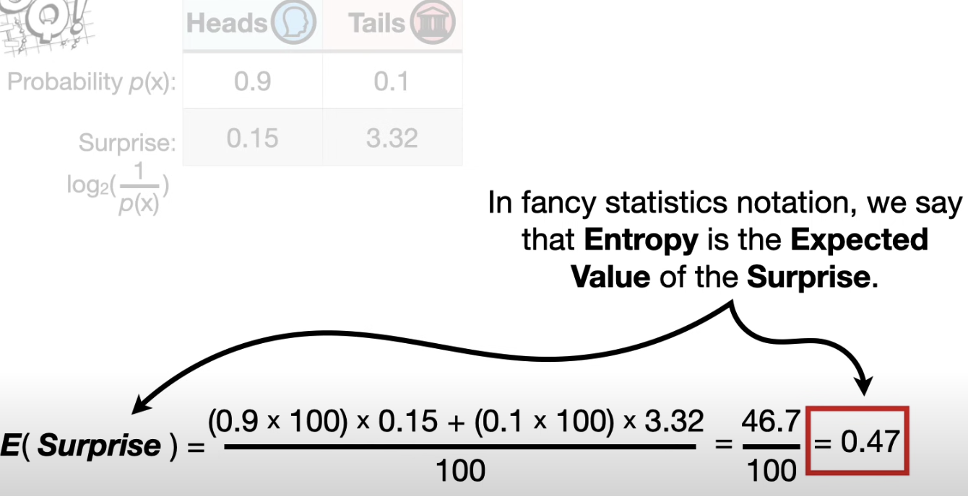

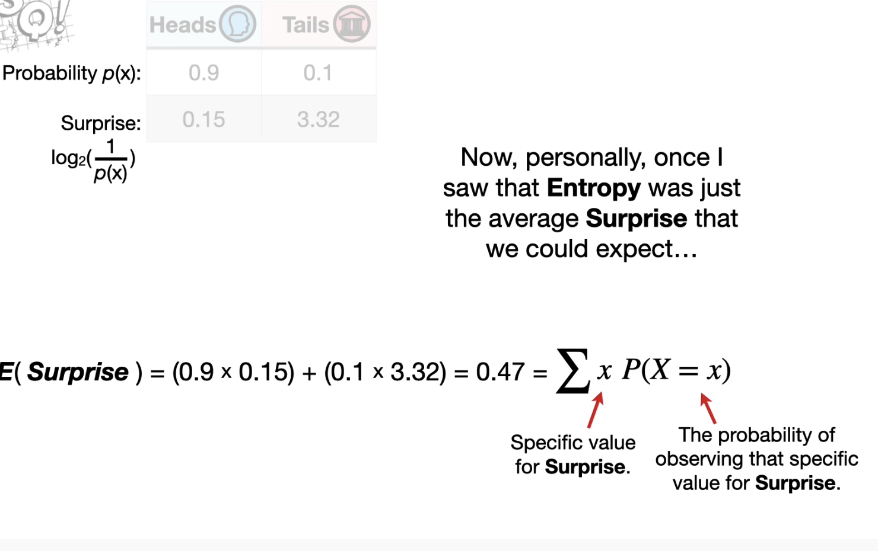

Entropy went from something that I had to memorize,   
To something that I could derive.

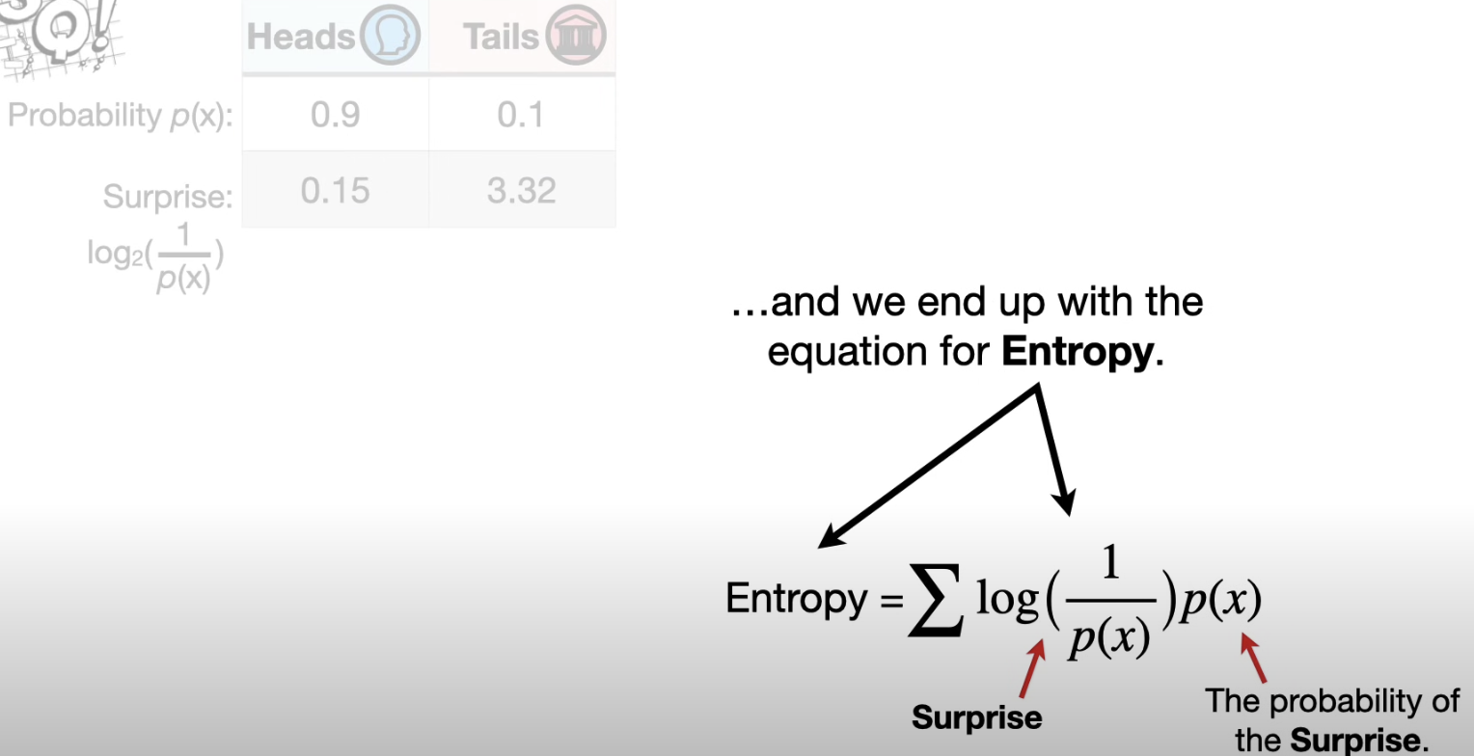

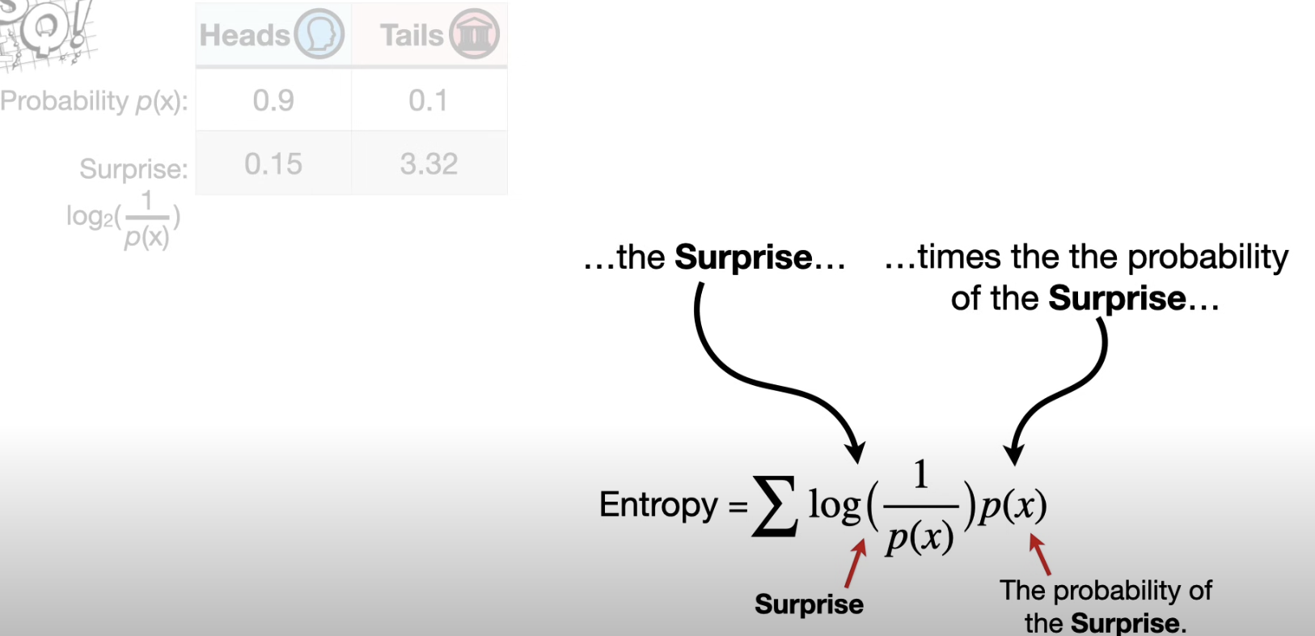

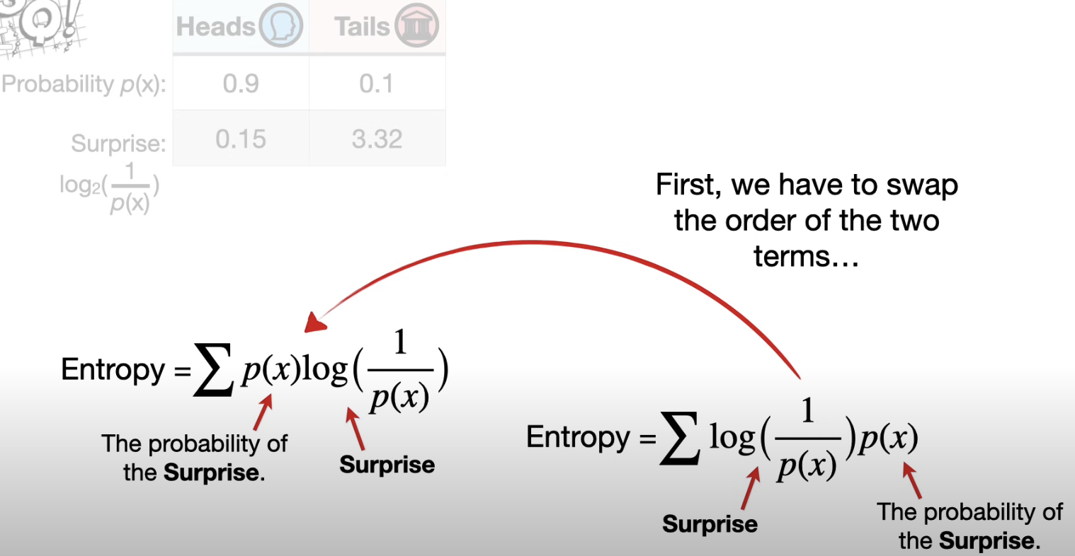

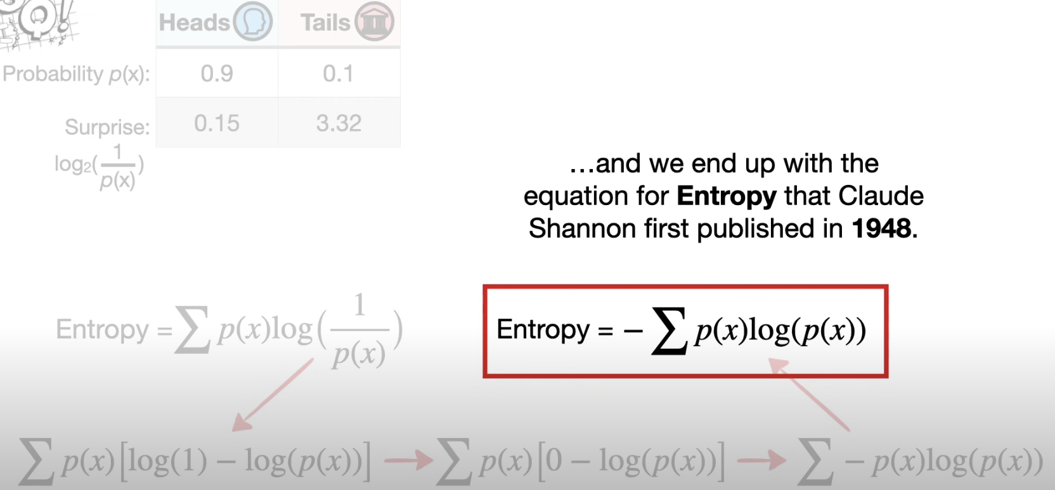

# **References**

<https://www.youtube.com/watch?v=YtebGVx-Fxw>